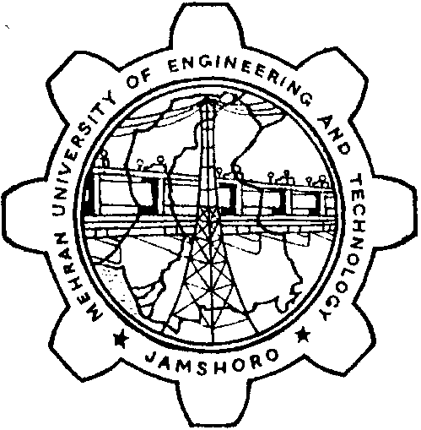 |  | MEHRAN UNIVERSITY OF ENGINEERING AND TECHNOLOGY, JAMSHORO
 |  | (FOR DIRECTOR / CHAIRMAN)
 |  |  |  |  |  |  |  | AWARD LIST
DEPARTMENT / INSTITUTE
PROGRAM
Title of Thesis / Project
NAME OF SUPERVISOR |  |  |  |  |  |  |  |  |  | Date of Conduct of Exam.
S.# | ID NUMBER |  |  | NAME OF STUDENT |  |  |  |  | Project / thesis evaluation & viva-voce
 |  |  |  |  |  |  |  |  | MAXIMUM MARKS
 |  |  |  |  |  |  |  |  |  |  |  |  | 50
 |  |  |  |  |  |  |  |  | Total Marks in Figure |  |  | Total Marks in Words
1.
2.
3.
4.
5.
6.

Signature of Director/ Chairman

Name:_________________________ Date: ___________

Note:- (i) Overwriting/ Correction, if any, must be Signed by the concerned Examiner

(ii) The use of any sort of Fluid Erasure is not Permissible.

(iii) In case of Director / Chairman being Internal Examiner the External will also award marks separately in the
award list specified for the use of Director/ Chairman

